Information Extraction

Source: https://people.ischool.berkeley.edu/~dbamman/nlp20_slides/21_IE.pdf

Named Entity Recognition
- Identify text corresponding to entities
- BIO notation: beginning/inside/outside entity
- Limitation: most datasets have flat structure, not useful for general entities
- Sequence labeling for BIO prediction (MEMM, CRF)
- Gazetteers: list of names in a type category (e.g. GeoNames → GEO, US SSN→ PER)

Entity Linking
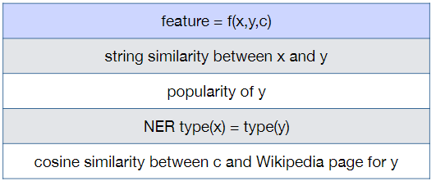
- Identify correct referent for a mention in context given list of candidate referents
- Learning to rank problem: for a mention , set of candidates and context , select highest scoring entity
- Scoring function:
- Need to minimize loss function:

Relation Extraction
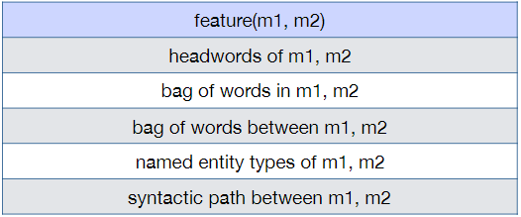
- Use regular expressions to extract high-precision relations (e.g. Hearst patterns)
- Supervised method
  - Add positional embeddings to define distance to head/tail
  - Represent tuple by aggregating all representations from sentences where it appears

